

**DEPARTMENT OF INFORMATION TECHNOLOGY**

**PROJECT TITLE:HOSPITAL MANAGEMENT**

**BY:KIOKO KELVIN**

**DECLARATION**

I hereby declare that this project report is based on my original work except for citations and

Quotations which have been duly acknowledged. I also declare that it has not been previously

And concurrently submitted for any other award at Zetech University

SIGNATURE: _________________

NAME: ______________________

REG NO: _____________________

DATE: _______________________

**SUPERVISOR**

I the undersigned do hereby certify that this is a true report for the project undertaken by the

Above named student under my supervision and that it has been submitted to Zetech University with my approval

Signature…………………………………………………….Date…………………………….

**ACKNOWLEDGEMENTS**

I would like to thank everyone who contributed to the successful completion of this project. I would like to express my gratitude to my research supervisor for his invaluable advice, guidance and his enormous patience throughout the development of the project.

In addition, I would also like to express my gratitude to my loving parent and friends who had helped and given me encouragement.

**Table of Contents**

**DECLARATION** ii

**ACKNOWLEDGEMENTS** iii

**LIST OF TABLES** vi

**LIST OF FIGURES** vii

**ABBREVIATIONS AND ACRONYMS** viii

ABSTRACT ix

**CHAPTER ONE** 11

**INTRODUCTION** 11

**1.1 Background information** 11

**1.2 Problem statement** 14

**1.3 Objectives of the Study** 15

**1.4** **Research questions** 15

**1.5 Justification of the proposed automated System.** 16

**1.6 Purpose of the Study** 17

**1.7 The project scope** 17

**1.8 Project risk and mitigations** 17

**1.9** **Budget and Schedule** 18

**CHAPTER TWO** 20

**LITERATURE REVIEW** 20

**2.1 Introduction** 20

**2.1.2 Medical informatics** 21

**2.1.3 Information security** 21

**2.1.4 Database** 22

2.2 Management Information System 22

**2.3 Prototyping** 24

**2.4 Information and Communication Technologies** 25

2.5 Components of Management Information Systems 26

**2.6 Existing software products** 27

**2.6.1 Geographic information systems** 27

**2.6.3 Patient Identification** 28

**2.6.4 Secure data transfer to enhance Integrity** 29

**2.6.5 Evaluation of health care Systems** 30

**2.7 System Quality** 30

**2.8 Summary** 32

**CHAPTER THREE** 34

**RESEARCH METHODOLOGY** 34

**3.0 Introduction** 34

**3.1 System Design** 34

**3.2 Target Population** 38

**3.3 Data collection techniques** 38

**3.4 Tools used to analyse the data and processes** 39

**3.5 Tools used to test and implement the system** 39

**3.6 Time schedule and project cost:** 39

**CHAPTER FOUR** 40

**SYSTEM ANALYSIS AND REQUIREMENT MODELLING** 40

**4.1 Introduction** 40

**4.2.1 Data Flow Diagrams** 40

**4.2.4 Flowchart for the login session** 44

**4.3 FACTS FINDING TECHNIQUE** 45

**4.4 SYSTEM REQUIREMENTS** 46

**4.5 Software and Hardware Requirements** 47

**CHAPTER FIVE** 49

**SYSTEM DESIGN** 49

**5.0 Introduction** 49

**5.1 Screenshots of the system designs** 49

**5.2 Physical Database Design** 51

5.3 Entity Relationship Diagram 53

**CHAPTER SIX** 54

**IMPLEMENTATION AND TESTING** 54

**6.1 Introduction** 54

**6.2 Coding and Testing Tools** 54

**6.3 MYSQL TRIGGERS** 54

**6.6 SYSTEM TESTING** 56

**6.7 System Test Plan** 57

**6.7.1 Test Case Results** 58

**6.9 Summary** 59

**LIST OF TABLES**

Table 1

ProjectRisk&Mitigations………………………………………………………….16

Table 2

Medicine Table..…………………………………………………………………………..…53

Table 3

Admin

Table…………..…………………………………………. …………………….54

Table 4

TestPlan Table……………………………………………………………………………....58

Table 5

Test Case Results………………………………………………………………..………….59

Table 6:

Budget……………………………….....…………..………….………………....68

Table 7:

Gantt Chart………………………………………………..……………………....69

**LIST OF FIGURES**

Fig 1: Waterfall Model………………………………………………...………………..………..…..34

Fig 2 DFDs of the hospital system….…………………………………………………………......…41

Fig 3 Context Diagram……………………………………………………………………………....44

Fig 4 Authentication DFD………………………………………………………………………...…44

Fig 5 Flowchart of the login Session………………………………………………………………….45

Fig 6 Sequence Diagram……………………………………………………………….…………….46

Fig 7 ERD…………………………………………………………………………………………….54

Fig 8 Md5 Encryption………………………………………………………………………………..57

**ABBREVIATIONS AND ACRONYMS**

**IS** Information System

**ICT** Information Communication Technology

**IEHR** Integrated electronic health record management system

**IT** Information Technology

**GIS** Geographical Information System

**MIS** Management Information System

**SDLC** System Development Life Cycle

# ABSTRACT

The aim of this project is to develop a system that automatically manages attendance listing, appointment reminder and follow-up of patients in health industry using secure technology. It will seek to develop the system that will effectively make a follow-up of patients by effective attendance recording and appointment reminder where patient a data are securely stored and transmitted. The proposal significance will to clearly demonstrate how patient’s information can be securely stored and transmitted hence enhancing patient’s privacy.

The project tends to come-up with a customized software system and can also apply to generic software systems. The proposed system will uses an evolutionary development software process model. This will be aided by such tools as CASE tools, ERDS, DFDS, structured English, decision tables, expert systems etc.The research techniques used include: observation, interviews, questionnaires and document review.

Data established that most patients and staff felt a need to move to an automated system and that it would perform better than the manual system. They expressed the need to have a system that could handle patients’ registration fast and effectively; one that could maintain records, attendance, appointments and follow-up.The study analyzed the unsecure health management system in place, it identified the problems experienced due to limitations of the manual and unsecure system as; complexity of dealing with the increasing number of patients, double registering, misplacement and misfiling of records and a difficulty in making appropriate follow-up.

Working from the observations and problems at hand, an automated and secure system is vital. This system can effectively handle the organizations’ welfare requirements. It can also produce the secure outputs required. The system also provides effective system security. It is a user friendly system that, even novice users can quickly learn how to use it.

The study’s main objective is to design a system that will secure patient information either in storage or on transmit.

.

**CHAPTER ONE**

**INTRODUCTION**

**1.1 Background information**

In a hospital where patients are taken care of, when a patient visits the hospital, the patient is an inpatient if he/she is admitted while is an outpatient when he/she is not admitted. Or a patient is rushed in case of emergency. Some patients go to a hospital just for diagnosis, treatment, or therapy and then leave as outpatients without staying overnight; while others are admitted and stay overnight or for several days or weeks or months as inpatients. Hospitals usually are distinguished from other types of medical facilities by their ability to admit and care for inpatients whilst the others often are described as clinics. When a patient enters the hospital the following sequence of operation is carried out.

First and foremost, the patient is registered in the card/registration room, and then the patient goes to the nurses workbench for examination (vital signs), the nurses then carries the patient folder to the doctors workbench for diagnosis. After the diagnosis, the patient is then sent to the laboratory for test or the patient is sent to the pharmacy for collection of drugs; the pharmacy section checks the patients prescribed drugs and cost them before the folder is sent to the bill office for billing.

After diagnosis the patient can also be referred to another clinic or to see a consultant in the same hospital. For example he/she may be referred for radiology services (CT scan, MRI, and ultrasound) or to special services like dental care. There may also be possibilities for surgical services. The inpatient may recover fully and be discharged or die and will be given a death report.

A Hospital is a place where patients visit to for medical checkup or diagnosis and treatment. Hospitals provide facilities like:-

* + Consultation and diagnoses of diseases by doctors.
  + Provision of treatment facilities.
  + Facility for admitting Patients (providing beds, nursing, medicines etc.)  Immunization of patients/children.

Various operational works are done in a hospital; all these works are done manually using papers as follows:

* + Recording information about the patients that visit a hospital for treatment.
  + Generating bills.
  + Recording information related to diagnosis given to patients.
  + Keeping record of the Immunization provided to children/patients.
  + Keeping information about various diseases and medicines available to cure them.

These are the various jobs that are done in a hospital by the operational staff and doctors; information about patients is recorded manually by just writing the patients name, age and gender. Whenever the patient visits, his information is stored again;

* + Bills are generated by recording price for each service provided to patient on a separate sheet and at last they all are summed up.
  + Diagnosis information to patients is generally recorded on the document, which contains patient information. It is destroyed after some time to decrease the paper load in the office.
  + Immunization records of children are maintained in pre-formatted sheets, which are kept in a file.
  + Information about various diseases is not kept as any document.

Doctors themselves do this job by remembering various medicines. All this work is done manually by the receptionist and other operational staff and lots of papers are needed to be handled and taken care of. Doctors have to remember various medicines available for diagnosis and sometimes miss better alternatives as they can’t remember them at that time.

* + 1. **Integrity issues in the health sector**

Inaccurate health information may adversely affect the quality of an individual’s  
healthcare, insurance, and employability. As computerization of health information  
continues and the scope of organizational exchange of health information widens into  
integrated health information exchanges (IHIEs), maintaining the integrity.   
The overarching goal of integrated health management system is to allow authorized users to quickly and accurately exchange health information to enhance patient safety and improve efficiency.  
Achieving this goal is dependent on the ability to link (match) multiple, disparate  
records relating to a single individual. Patient identity integrity is the accuracy, quality, and completeness of demographic data attached to or associated with an individual patient. This includes the accuracy and quality of the data as it relates to the individual, as well as the correctness of the linking or matching of all existing records for that individual within and across information systems. There are tremendous potential benefits and cost savings within the healthcare  
industry contingent on accurate patient identification and interoperability. Participation  
in using integrated health management system can also provide increased efficiency in the delivery of healthcare by permitting access to more complete and timely information regarding individual patients. Some of the issues that the management faces concerning the integrity of information include;

* Identifying and Reducing Improper Payments
* Preventing and Detecting Medicare and Medicaid Fraud
* Ensuring Patient Safety and Quality of Care
* Avoiding Waste and Promoting Value in Health Care
* Ensuring Efficiency and Effectiveness of Medicare and Medicaid Program Integrity Contractors
* Grants Management and Administration of Contract Funds
* Protecting Consumers of Food, Drugs, and Medical Devices
* Integrity and Security of Health Information Systems and Data

**Why This Is a Challenge**

As health care providers modernize their medical recordkeeping and billing systems, the adoption of integrated electronic health records management system (IEHR) and other innovations offer opportunities for improved patient care and more efficient practice management. However, as growing quantities of personal medical information are stored in electronic format, protecting the privacy and security of these data and ensuring the integrity of IEHRs is critical. In addition, ensuring the integrity, privacy, and security of sensitive data will be critical to the successful administration of the ACA Exchanges and related programs, including the premium tax credit program.

**Data Security.** A series of audits revealed that some hospitals lack sufficient security features, potentially exposing patients' electronic protected health information to unauthorized access. Vulnerabilities included unsecured wireless access, inadequate encryption, authentication failures, and other access control vulnerabilities. The audits also reveals that security breaches in data stored by CMS's contractors. Department must ensure that recipients of Medicare and Medicaid EHR incentive payments truly qualify for payment and that policies effectively promote desirable technological practices and outcomes. Department must implement Medicare payment reductions for physicians who cannot demonstrate meaningful use of certified EHR systems.

Finally, IEHRs should facilitate more accurate billing and support better quality of care but, when misused, may promote fraudulent billing or inappropriate care. For example, cut-and-paste features and auto-fill templates can reduce paperwork burdens, but can also be misused to fabricate information, generating improper payments and corrupting patients' records with inaccurate and potentially dangerous information. Similarly, well-designed decision support tools can help physicians select the best care for their patients, but inappropriately designed decision support tools can promote waste and inappropriate care.

**1.2 Problem statement**

In my stay at the institution I noticed there was a problem when it comes to registering, appointments and making a follow-up of the patients as data is stored in plain text both in station storage and transmission. The problem is, that patient data is stored as a plain text giving unauthorized user access to patient’s treatment and diagnosis status. Other problems included; double registering, inefficiency, increasing number of patients and un-able to make appropriate follow-ups. It is for this reason, a patients Registration, Attendance listing, Appointment reminder and Follow-up management system which is secure and reliable is needed to cub this problem and enhance data security. The purpose of the integrated health management system is to automate the system for storage and easy retrieval of data, flow of information and management of hospital. Patients’ records are in file manual format. Registering and appointments is done manually and in unsecure manner. Initially, the system was okay; due to few number of patients but due to an increasing number of patients i.e. 2000 patients a month, the manual system is becoming ineffective and inefficient in terms of data storage and transmission. Other problems are highlighted in detail below

* **Lack of immediate retrieval**: -The information is very difficult to retrieve and to find particular information e.g. - To find out about the patient’s history, the user has to go through various registers. This results in inconvenience and waste of time.
* **Lack of immediate information storage**: - The information generated by various transactions takes time and efforts to store them.
* **Error prone manual calculation**: - Manual calculations are error prone and takes a lot of time, this may result in incorrect information. For example, calculation of patient’s bill based on various treatments.
* **Preparation of accurate and prompt reports**: - This becomes a difficult task as business intelligence is difficult, this is due to lack of information collation (ability to put information together and analyze them).

**1.3 Objectives of the Study**

1. Design an appointment reminder mechanism that is tied to patient’s phone.
2. Design a system that will ease identification of patients who miss clinic on their appointment date.
3. Reduce the visibility of patient data to unauthorized individuals.
4. Make real-time and effective notification direct to patient’s phone.
5. Develop a system with enhanced data security so that the hospital data and information are stored centrally in a secure fail safe database that has a secondary backup database.
6. Ensure confidentiality of patients’ records stored in the database in encrypted format.
   1. **Research questions**
7. What will be the best encryption algorithm to use while encrypting data?
8. What type of appointment reminder will be designed?
9. Will the system identify the patients who miss the clinic?
10. Will the system reduce the visibility of patient’s data to unauthorized personnel?
11. Will the system make real time and effective notification direct to patient’s phone?
12. Will the system ensure confidentiality of patient’s records in the database?

**1.5 Justification of the proposed automated System.**

The need for an Automated Hospital Management System can be summarized as follows:-

* **Planned approach towards work**: - The activities in the organization will be well planned and organized. The data will be stored properly in data stores, which will help in retrieval of information and in enforcing security.
* **Accuracy**: - The level of accuracy in the proposed automated system will be higher. All operations would be done correctly and accurately. In practice, errors are not completely eliminated, they are reduced.
* **Reliability**: - The reliability of the proposed system will be high as information is stored properly and securely.
* **No Redundancy**: - In the proposed system utmost care would be taken to ensure that no information is repeated anywhere, in storage. This would assure economic use of storage space and consistency in the data stored.
* **Immediate retrieval of information**: - The main objective of the proposed system is to provide for a quick and efficient retrieval of information. Any type of information would be available whenever users require them.
* **Integrity**-This proposed system will prevent unauthorized personnel from getting access to the health resources without having the correct login credentials and privileges.
* **Immediate storage of information**: - In manual system, lots of problems are encountered in trying to store large amount of information.
* **Easy to Operate**: - The system should be easy to operate and should be such that it can be developed within a short period of time and fit the limited budget of the user.

**1.6 Purpose of the Study**

To design and develop a system that will effectively and securely manage patients registration, appointments and attendance therefore quicken follow-ups hence reduced number of deaths caused by communicable disease.

**1.7 The project scope**

The hospital management system is capable of supporting any number of staff of the hospital and each module of the package runs independently without affecting other modules. This means that all departments of the hospital work independently.

**SERVER EDITION (SE):** This edition is Microsoft window based automated hospital management system server that will be running on the oracle database oracle database.

**CLIENT EDITION (CE):** This edition is a Microsoft window based Hospital Management System client, which must be developed and pre-installed in each of the client computers in the hospital before **1.8 Budget and Schedule**

**1.8 Project risk and mitigations**

**Table 1 Projects Risks and Mitigation**

|  |  |  |  |
| --- | --- | --- | --- |
| **NO:** | **RISK** | **QUESTION TO ASK** | **ACTION TO TAKE(MITIGATION)** |
| 1. | Financial Risk | Will I be able to fund the project? | Will ensure to effectively meet the budget through self-funding, and in case I cannot, I will try to source for funding in terms of short term loan to make sure that the project does not derail. |
| 2 | Resignation of my supervisor | What will happen in case a supervisor assigned to me resigns in the middle of the project? | This will be so unfortunate, as it can lead to derailing the project. However; to avoid derailing the project, I will communicate to the IT coordinator to ensure that he is aware of the situation and ensure that I have another supervisor. |

* 1. **Budget and Schedule**

**1.9.1 Budget**

Capital will be required to develop the proposed website since some resources such as software, labour and all the expenses incurred. There is an estimation that it will cost roughly ksh 52,100(521$ dollars).

Some of the requirements include;

a) A laptop that will be used to code the system as well as testing. The laptop minimum requirements are, 64 Bit Windows 7 Operating System, Duo core processor6, 2GB Ram and an internal memory of 500gb.This will enhance performance of the system.

b) External storage-They include the external hard disk that have a higher capacity than the internal computer memory. It efficient for security purposes in case the computer internal storage crashes thus provides a backup facility.

c) Printer-It’s an electrical device that will be used to test whether the system can produce hard copies of information in the system such as reports and records. Inject printer will be used since it produces high quality prints.

d) Notepad, Dreamweaver-They are text editors that will provide an environment where the designer will write the system codes.

***Diagram in Appendix III:***

***1.9.2 Schedule***

The system will be developed for a period of six months, since the system is dynamic and more interactive thus it will require more time to ensure all aspects of the system are covered to maximum.

a) *1st month*-It will involve assessing and defining the problems of the bus station and passengers are facing. The requirements will be gathered either by interviews, Questionnaires with the management of staff.

c)*2nd month*-It will encompass system analysis. The system will be documented and reviewed with the customer and analysing all what will be entailed in the system.

c) *3rd month*-It will involve the design actual system. It will involve defining the architecture, components, modules, interphases and data for the system to satisfy the specified requirements.

d) *4th month*-It will involve coding of the system using text editors such as dream weaver and notepad.

e) *5th month-*In this phase, I will test the project by performing several tests such as unit testing,intergration testing and a final validation testing to check for errors and bugs.

f) *6thmonth*-It will involve writing the user manual of the proposed system.

***Diagram in Appendix IV:***

**CHAPTER TWO**

**LITERATURE REVIEW**

**2.1 Introduction**

Busha and Harter (1980) regard a literature review as “an attempt to identify, locate and synthesize completed research reports, articles, books and other materials about the specific problems of a research topic.” A theoretical basis must always form the basis upon which a research project or study is conducted. The theories and knowledge about a specific area of study help to clarify what is already known, it helps to formulate more clearly the problem area and shows forth the gaps in knowledge that the study seeks to fill.

This chapter elaborates the kind of literature, which has been developed by other researchers in this project field. It expresses the views of other people in relation to the systems in general, automated systems, medical system and the systems development life cycle, which will be as a guide to the development of the project. In this review, the coverage takes an account of a wide range of literature from various printed and non-print media.

It is the information technology that has helped to enforce the pace of change in industry, commerce, government and certainly healthcare sectors. It’s evident in our modern hospitals. It encourages a hot pursuit of efficiency and economy through copious and rapid exchange of health information.

**2.1Computersinhealthsystems**Computers have a very significant impact on the quality of medical services (P.M. Heathcoat, 2001) e.g.

* Medical records stored in hospitals information systems improve the quality of patient care. They are more accurate, they keep track of patients’ prescriptions and tests administered, hospital admissions, dietary requirements and so on. Records are less likely to go astray than manual records and they can be made available to automated people at any location
* Computerized monitory devices can keep a 24hr watch on any critically ill patients and sound the alarm if vital signs change for the worse
* Expert medical systems can help to diagnose diseases often at remote locations far from the care of a specialist. Vast amounts of data on symptoms and illness are stored in ‘knowledge base’ which can help a doctor to arrive at a preliminary diagnosis.

Fielt, (1976) defines a medical system as a societal mechanism that transforms generalized inputs (work force, mandate, knowledge, money and data) into specialized outputs in form of medical services to solve health problems of society. He emphasizes that modern medical systems are characterized by a complex division of labour which require application of technological input for efficiency. Similarly, types of medical facilities have proliferated with the increased sophistication and complexity of medical instruments and techniques.

Myles, (1987) describes gross medical product as the transaction that constitutes the services of a medical system. He also identifies education and research component to constitute the afore-mentioned services. The research component is primarily an elaboration and application, in the medical system, of generally for diagnostic and records keeping.

**2.1.2 Medical informatics**

Anderson (1976) defines medical informatics as the complex processing of medical data by computers to produce new kinds of information that may be useful in performing medical duties.

Zielstoffi. R.D. (1984) coined the phrase “Health Informatics” which he defined as the use of Information Technology (hardware and software), with information management concepts and methods to support the delivery of healthcare. He describes the medical informatics as those collected informational technologies which concern themselves with patient-care and decision making process performed by healthcare practitioner

**2.1.3 Information security**

Thomas W. Mandron (1994) says there is no universal agreement on what constitutes security or at least appropriate security in a computing and communications environment. Indeed, in many organizations there is a debate over whether security is needed at all, or whether the level of security provided is too much or too little. The 3 broad areas of security with which we must be concerned: information security, physical security, and disaster recovery. A somewhat broader list of concerns would include security issues revolving around the data center, distributed processing, mini and microcomputer controls and end-user access. A more extensive security list might include physical, personnel, data, application software, system software, telecommunications and operations.

S. Rao Valabhaneni has suggested that in order to implement necessary security, it is important to activate 5 types of controls; directive, preventive, detective, corrective and recovery. To this list we might also add 2 more ephemeral and often overlooked controls; legal and ethical.

**2.1.4 Database**

Mark Chasin (1976) defines a database as a simple collection of information organized in some logical way. The organization of the information in a database makes it possible to search through it logically and quickly i.e. computerized databases speed the search process considerably.

P.M Heathcote (2001) says the main difference between computerized and non-computerized database is the speed with which data can be accessed. Information that would previously have taken weeks or even years to gather and collate can now be gathered in a few seconds. A computerized database also makes it possible to analyze data in ways that were previously unthinkable.

Heathcote (2001) adds, the software that is used to access, update and manipulate the data in a computerized database. The advantage of database system include

* Database independence
* Quality of management information
* Control over redundancy
* Consistency of data
* More information available to users
* Greater security of data
* Less time inputting data

### 2.2 Management Information System

Information Systems (IS) can be defined as a set of interrelated and interacted elements or components that collect, store, process, and report data and information that can be used to enhance the process of decision making (Al-adaileh, 2008). Kettinger (1995) argued that Information system function can be defined as production and service activities performed by a centralized information system department in the organization. IS has gone through many phases. In the 1960s data processing was a backroom function with little customer interaction. The main purpose at that time was to develop and maintain a highly reliable transaction-based system. In the 1970's, the role of IS was a distributive computing and decision support technology, which requires an increased level of user interaction and participation. In the 1980's the IS was known to be decentralized with nine sub-functions: delivery system, system development, support center, information center, R&D, technology diffusion, planning, internal auditing, and administration. Recently, IS has come to handle business transactions between IS service providers and customers. Therefore, IS roles have changed from manufacturing activity to distribution and technology transfer that require higher levels of user interactions and service delivery. It is wise for IS developers to refer to the corporate business plan and corporate culture before developing MIS.In many industries, survival and even existence is difficult without extensive use of IT. ISs have become essential for helping organizations operate in a global economy. Organizations are trying to become more competitive and efficient by transforming themselves into digital firms where nearly all core business processes and relationships with customers, suppliers, and employees are digitally enabled. Businesses today use ISs to achieve six major objectives: operational excellence; new products, services, and business models; customer/supplier intimacy; improved decision making; competitive advantage; and day-to-day survival. From a technical perspective, an IS collects, stores, and disseminates information from an organization’s environment and internal operations to support organizational functions and decision making, communication, coordination, control, analysis, and visualization. ISs transform raw data into useful information through three basic activities: input, processing, and output. From a business perspective, an IS provides a solution to a problem or challenge facing a firm and provides real economic value to the business.

An IS represents a combination of management, organization, and technology elements. The management dimension of ISs involves leadership, strategy, and management behavior. The technology dimensions consist of computer hardware, software, data management technology, and networking/telecommunications technology (including the Internet). The organization dimension of ISs involves the organization’s hierarchy, functional specialties, business processes, culture, and political interest groups.Whitten, Bentley, and Dittman (2001) define an information system as “an arrangement of people, data, processes, information presentation, and information technology (IT – hardware, software, and telecommunications) that interact to support and improve day-to-day operations in a business as well as to support the problem-solving and decision-making needs of management and users.”

Flynn (1992) defines an information system (IS) as that, which “provides procedures to record and make available information,” According to him, the aim of an information system is to provide a means for processing information to improve efficiency and effectiveness of the organization.

Jessup and Velacich (2003) defines information systems as combinations of hardware, software, and telecommunications networks that people build and use to collect, create, and distribute useful data, typically in organizational setting.” They exhibit an information system as a combination of five key elements i.e. people, hardware, software, data, and telecommunications networks.

O’Brien (2003) defines an information system as “any organized combination of people, hardware, software, communication networks, and data resources that collects, transforms, and disseminates information in an organization”.

**2.3 Prototyping**

Prototyping according to Kendall and Kendall (2002), the prototyping Model was developed on the assumption that it is often difficult to know all of your requirements of a project. Typically, users know many of the objectives that they wish to address with a system, but they do not know all the nuances of the data, nor do they know the details of the system features and capabilities. The prototyping Model allows for these conditions, and offers a developments approach that yields results without first requiring all information up-front.

In prototyping, the developer builds a simplified version of the proposed system and presents it to the customer for consideration as part of the development process. The customer in turn provides feedback to the developer, who goes back to refine the system requirements to incorporate the additional information.

**Evolutionary Prototyping**

Kendall and Kendall (2002) lists evolutionary prototyping as one of the major type of prototyping. Evolutionary prototyping is used to build a very robust prototype in a structured manner and constantly refine it. This is because when an evolutionary prototype is built, it forms the heart of the new system and the improvements and further requirements will be incorporated

When developing a system using evolutionary prototyping, the system is continually refined and rebuilt. It evolves in the knowledge that we do not understand all requirements and builds only on those that are well understood.

In this study, the researcher decided to use evolutionary prototyping as a method of data collection since the researcher considered user involvement in the development of the system as major boost in determining the requirements of the system.

In addition, the researcher felt that due to the limited time available for the development of the system, the interaction between the users and the system will help come up with the required system within a short period.

Furthermore, prototyping proved to be an efficient method since the users did not fully understand their needs and were not fully aware of the benefits that the upcoming cell – phone marketing system would provide them.

**2.4 Information and Communication Technologies**

Libbie Driscoll(Nov,2001), Final Report to the International Development Research Centre, In view of the enormity of the pandemic and the urgent need to make the best use of all resources and tools available, it is but natural that the new Information and Communications Technologies (ICTs) are seen as one major, potential tool, among others, in the global mobilization and response to the pandemic. The promise of ICTs is based on the feasibility, at relatively low cost, of providing access to information and knowledge for those working on the problem, to those who are suffering from the disease or its effects, and to those who need to take preventive actions. It allows for networks that have the potential to link partners in different spheres and locations local level activities and responses .A number of larger issues related to ICTs and development have been of wide concern to development groups. The North - South split in access to information and communication technologies, called the digital divide, has been a source of concern to many. As economic growth is increasingly associated with knowledge, it is argued that the digital divide will intensify the pre-existing economic divide as ICTs are seen as the primary source, repository and tool for generating and disseminating knowledge. Researchers and practitioners provide a very wide range of views on the positive and negative aspects of the potential of ICTs on the broader developmental objectives

It must be said at the outset that ICTs cannot provide the same kind of direct benefits such as drugs or care, to those currently afflicted nor can they meet some of the most pressing needs of the surviving members of families who may be without food or shelter. The immediate needs of those affected are so obvious and the resources available so inadequate, that any resources allocated to ICTs can seem a misplaced luxury. But we suggest focused applications of ICTs and appropriate policies that empower intermediary groups such as community institutions, health care providers, and those working with the poor and vulnerable groups, can make good use of ICTs to improve the lives of people living with communicable diseases Therefore, these new technology options need to be explored and exploited in appropriate ways. A practical approach suggests that while ICTs may not be the most critical single element to development or to the challenges related to COMMUNICABLE DISEASES, these technologies can make useful contributions within an appropriate framework.

### 2.5 Components of Management Information Systems

These are complete Information Technology subsystems that make the reservation Information System operational; they are compatible in nature and the failure of one component may affect the operation of the others with in the system. They consist of computer resources, data, people, and procedures used in the modern business enterprise.

**2.5.1 Hardware**

O‟Brien (2001) defines hardware as individual physical devices and material used in information processing. Specifically, it includes not only machines like computers but also data media i.e. all tangible objects on which data are recorded from sheets of paper to magnetic disks. Others include keyboards, mouse, printers, scanners etc.

**2.5.2 Software**

A software includes all sets of information processing instructions and it comprises of different types of programs that enable the hardware to carryout different tasks. Software is further categorized into system software and Applications software. System software is concerned with keeping the computer system working while Application software is the general purpose or written for a specific task like stock control. It may be written using a programming language or more general purpose piece of software such as database.

**2.5.3 People**

According to OBrien (2001) , these are required for the operation of all information systems. They include end-users and information system specialists. End-users are people who use an Information System. The reservation information system specialists help in the development and operation of information system. They include system analysts, programmers, computer operators and others. People, are probably the component that most influence the success or failure of information systems.

**2.5.4 Procedures**

These are set of instruction about how to combine the above components in order to process the information and generate the desired output. They consist of the way how to log on to the DBMS, use of different forms and manipulations throughout the project.

**2.6 Existing software products**

**2.6.1 Geographic information systems**

Geographic Information Systems (GIS) allow many different types of data to be geographicallyviewed, organized and analyzed. This information can be used to make decisionsabout the allocation of health care and prevention interventions (Rushton, 2003). In the fightagainst Communicable diseases, GIS technology has been used in several different ways, includingfor spatial epidemiology, locating high-risk populations and prevention services, and understandingbarriers and access to care among people with Communicable diseases.

**2.6.2 Integrity issue for the patient information exchange within a HIE**  
The overall goal of HIE is to provide a patient’s requested clinical information in real time  
and in a format that allows it to be used effectively by the provider currently seeing the  
patient. To achieve this purpose the HIE may provide the requested information in a  
variety of ways. For example, accepted formats for exchange documents are varied and  
include the Continuity of Care Document (CCD) or Continuity of Care Record (CCR),  
scanned documents in PDF, TIFF or other format, HL7 records, plain text records, and  
Ensuring Data Integrity in Health Information Exchange AHIMA THOUGHT LEADERSHIP SERIES The overall goal of HIE is to provide the patient’s requested clinical information in real time and in a format that allows it to be used effectively by the provider currently seeing the patient.  
the like. In most cases the document formats are dependent on the original source formatting. The “gold standard” is a document that can be “parsed” to provide discrete  
data elements that can be incorporated into the current provider’s electronic health  
record (EHR) using standard mapping and conversion techniques.  
Although many HIEs have the ability to translate documents into other formats,  
providing such a service is expensive and requires constant maintenance and review.  
Therefore, the HIE itself often only provides a view of a document provided by  
another source.  
Many HIEs are still developing their business models and working to establish transactional  
volumes and records to ensure HIE viability and sustainability. In order to maximize  
record volume they are willing to work with provider systems to accept records in a  
variety of formats. More fully developed HIEs permit participating providers to retrieve  
data elements in standardized formats, which may then be incorporated within the  
provider’s EHR. The actual incorporation of these data elements into the provider  
systems is the responsibility of the provider. One strategy some HIEs have adopted,  
and which others are considering adopting, is incorporation of both the NHIN and  
the Direct Project protocols in order to facilitate electronic information access.  
**Incorporating the HIE’s information into a participant’s medical record-**There are three models with regard to incorporating patient information obtained from  
the HIE. One model permits cut and paste with attribution; one model permits scanning  
the report itself into the chart so that the source is visible; and the third model permits  
summarizing the content of the received information. The policy in each case is  
determined by the HIE’s board of directors.

**2.6.3 Patient Identification**

How a patient’s information is maintained, corrected, or updated when new information is sent to the HIE  
A combination of automated and manual processes are in use in various HIEs to  
maintain the integrity of any EMPI. Typically the HIE uses the same processes as a  
self-contained EMPI. It is continuously updated by data sources regarding patients  
who have opted in and out of the exchange. To a greater or lesser extent, historical  
information is maintained with all updates as patient matching algorithms match new  
patient demographic information against existing information. Systems that rely on the  
algorithm usually set a confidence level, so that if a match does not meet a confidence  
threshold, then a new patient is created. A report is periodically run to identify likely  
matches subsequently reviewed by the HIE staff. Depending on staffing availability,  
HIE staff follow up with the submitting facilities as necessary to verify the validity of the  
demographic data. Corrections are made as necessary and when indicated. Duplicate  
patients are merged or linked. Many HIEs also receive HL7 merge messages from each  
participant. These messages are routed into a work queue and patients are electronically and manually merged, linked, or updated. The processes to correct demographic data depend on the individual HIEs and their agreements with the participating hospitals or providers. At a minimum, the HIE’s policy should clearly state who can initiate a correction, what notifications are required   
(by whom, and to whom), and within what time frame of the correction.**nsuring Data I**

**2.6.4 Secure data transfer to enhance Integrity**

HIEs employ a combination of approaches depending on their integration architecture.  
Some examples include an encrypted virtual private network for interfaced clients, secured sockets layer (a protocol for encrypting information over the Internet) or secured  
portal with applicable HIPAA safeguards (password complexity, timeouts, and so forth)  
for portal users. Of the HIE survey respondents, all are committed to providing secure clinical data  
exchange as defined by ONC and HITSP, including public key encryption and hardware/ software tokens. ONC recognizes that secure data transfer is essential from both a security and privacy perspective. A clinical message service that meets industry security standards will be utilized and required for HIE certification. For example, the Commonwealth of Virginia HIE is committed to implementing the HITSP Secured Communication Channel Transaction to provide the mechanisms to ensure the authenticity, integrity, and confidentiality of transmissions, and the mutual trust between communicating parties. Their objectives include providing:

» Mutual node authentication to assure each node of the other’s identity  
» Transmission integrity to guard against improper information modification or  
destruction while in transit  
» Transmission confidentiality to ensure information in transit is not disclosed to  
unauthorized individuals, entities, or processes

**2.6.5 Evaluation of health care Systems**

In 1995 van der Loo conducted a literature review to classify evaluation studies of information systems in health care (van der loo et al 1995). The primary objective was to get an insight into the variety of evaluation methods applied. In all, 76 studies published between 1974 and 1995 were included in the review. Many different performance measures or success factors were applied in the studies reviewed. The review’s main conclusion was that the evaluation methods and effect measures depended on the characteristics of the information system under evaluation. However, the range of identified evaluation methods and effect variables was broad for every type of system. Among the effect variables were costs, changes in time spent by patients and health care personnel, changes in care process, database usage, and performance of users of the system, patient outcomes, job satisfaction, and the number of medical tests ordered. Several authors have suggested approaches to evaluating information technology in health care (Anderson et al 1997). These approaches concerned assessment of technical, sociological, and organizational impacts. A literature review by Delone and McLean 1992 in the field of management information systems aimed at identifying determinants for system success. They presented a framework with six dimensions of success -:

1) system quality, (2) information quality, (3) usage, (4) user satisfaction, (5) individual impact, and (6) organizational impact

The purpose of their review was to analyze evaluation studies of inpatient patient care information systems requiring data entry and data retrieval by health care professionals, published between 1991 and May 2001, to determine the attributes that were used to assess the success of these systems and to categorize these attributes according to the Delone and McLean framework. They also examined how the attributes were measured and what methodologies were used in the evaluation studies. Their review did not cover outpatient.

**2.7 System Quality**

Delone and McLean 1992, proposed to subdivide success measures of management information systems into six distinct categories that define the five dimensions to measuring success of system deployment as follows: (1) system quality, (2) information quality, (3) usage, (4) user satisfaction, (5) individual impact, and (6) organizational impact. Within each category several attributes could contribute to success.

The information processing system itself is assessed with system quality attributes (e.g., usability, accessibility, ease of use). Information quality attributes (e.g., accuracy, completeness, legibility), concern the input and output of the system. Usage refers to system usage, information usage, or both. Examples of attributes of usage are number of entries and total data entry time. User satisfaction can concern the system itself or its information, although they are hard to disentangle. Delone and McLean included user satisfaction in addition to usage, because in cases of obligatory use, user satisfaction is an alternative measure of system value. Individual impact is a measure for the effects of the system or the information on users’ behavior, and attributes can be information recall or frequency of data retrieval or data entry. Organizational impact, the last category, refers to the effects of the system on organizational performance. Thus, success measures vary from technical aspects of the system itself to effects of large-scale usage.

DeLone and McLean 1992 concluded that success was a multidimensional construct that should be measured as such. In addition, they argued that the focus of an evaluation depended on factors such as the objective of the study and the organizational context. Furthermore, they proposed an information system success model in which the interdependency—causal as well as temporal —of the six success factors was expressed. In their view, success was a dynamic process rather than a static state; a process in which the six different dimensions relate temporally and causally. System quality and information quality individually and jointly affect usage and user satisfaction. They influence each other and have a joint influence on user behavior.

A study was conducted in 2004 by Healthcare Informatics in collaboration with American Health Information Management Association (AHIMA ) to measure the level of readiness of health information management (HIM) professionals and the extent of(Electronic Health Record) EHR implementation in their organization. The findings showed the industry is continuing to see more movement toward EHR. For example, when organizations were asked to describe their progress toward an EHR, 17 percent of respondents indicated they were extensively implemented; 26 percent indicated they were partially implemented; 27 percent said they were selecting, planning, or minimally implemented, and 21 percent indicated they were considering implementation and gathering information about it (Minal Thakkar and Diane .Davic August 14 2006).

In a study conducted during the summer of 2004 by the American Academy of Family Physicians (AAFP), nearly 40 percent of respondents, who were members of AAFP, indicated they either had completely converted to EHRs or were in the process of doing so. Twenty-four percent had purchased the EHR system within the first half of the year. Findings showed that cost remained a major barrier for physicians in small and medium practices in the move to EHR systems. Previous research on risks of EHR systems identified privacy and security as major concerns. Other risks identified were financial risk (billing errors in software), software systems becoming obsolete, software vendors going out of business, computer crashes, data capture anomalies, programming errors, automated process issues, and populating invalid information in the decision support systems module of EHR systems.

**2.8 Summary**

Ensuring data quality is not a trivial task. Ideally, the health data in an electronic record  
should be accurate, up-to-date and complete; but unfortunately the real world is far  
from ideal. High-quality data requires us to have a very clear understanding of the meaning, context, and intent of the data—unambiguous and, ideally, standardized computable definitions of data that can form the basis for future safe decision making. To facilitate data quality, the ultimate goal of any HIE should be accurate identification of the patient. HIE patient identity and administration has three patient identification profiles: (1) the patient identifier cross-reference profile that matches patients by cross-referencing IDs; (2) the patient demographics query profile queries a central patient information server; (3) patient administration management knows where the patient is, was, or is going. In addition the HIE should assign a unique patient/person identifier by using advanced record matching techniques, for example, probabilistic algorithms, and manual processes, as needed. Nine influences have been identified as industry standards: system interfaces, algorithms, unique identifiers, business processes, data accuracy, data quality, training, and medical devices. Very high MPI duplication rates have been identified in all arenas. Meeting industry standards regarding data quality could therefore produce tremendous benefits both in terms of monetary savings and quality of care. Quality information is essential to all aspects of today's healthcare system, so improving the quality of data, information, and knowledge is paramount as we transition from paper to EHRs. Many errors and adverse incidents in healthcare occur as a result of poor data and information. In addition to threatening patient safety, poor data quality increases healthcare costs and inhibits health information exchange, research, and performance measurement initiatives. HIM professionals play a critical role by leading initiatives related to standards, technologies, education, and research that are vital for capture, use, and maintenance of accurate healthcare data and facilitating healthcare’s electronic evolution.

**CHAPTER THREE**

**RESEARCH METHODOLOGY**

**3.0 Introduction**

This chapter focuses on the methodology that will make this project complete and working. A methodology is a frame work that is used to structure, plan and control the process of developing an information system that include predefinition of specific deliverables and artefacts that are created and completed by project team to develop and choose methodology factors such as knowledge base, nature of system as well as data and operation requirements to be considered in the development of the system.

**3.1 System Design**

According to A. Vision D. & Fitz Gerald D,a system is a group of interdependent items that interact regularly to perform a task. A computerized system is developed through a process called System Development Life Cycle (SDLC).SDLC is a logical process used by a systems analyst to develop an information system, including requirements, validation, training, and user ownership. Any SDLC should result in a high quality system that meets or exceeds customer expectations, reaches completion within time and cost estimates, works effectively and efficiently in the current and planned Information Technology infrastructure, and is inexpensive to maintain and cost effective to enhance. It adheres to important phases that are essential for developers, such as planning, analysis, design, and implementation, therefore in regards to my system and since it’s an online I choose to use waterfall model.

However, as the SDLC was used on so many large-scale developments which ran into trouble, the SDLC became tarnished with a reputation for inefficiency.

**Waterfall model**

The waterfall model will be used to develop the system because it leads to rational and systematic development. This aims to produce high quality system that meets or exceeds customer expectation by reaching completion within the time and cost estimates, works effectively and efficiently in the current plan. It is very simple to understand and use. In the waterfall model, each phase must be completed fully before the next phase can begin. At the end of each phase, a review takes place to determine if the project is on the right path and whether to continue. Waterfall model phases do not overlap. The alternative of waterfall model is the ***incremental model*** which is a method of software development where the product is designed, implemented and tested incrementally until the product is finished. It involves both the the development and maintance.Here the product is decomposed into a number of components each of which is designed and built separately. Each component is delivered to the client when its complete and this allows partial utilization of the product and avoids a long development time. It also avoids a large capital outlay and subsequent long waiting period. This incremental model helps to ease the traumatic effect of introducing a completely new system all at once.

The waterfall model incorporates five stages in system development process.

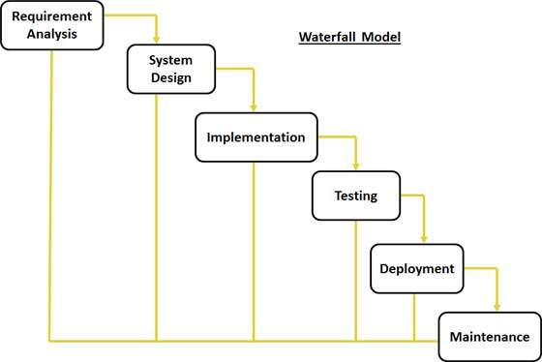

Fig 1 (Waterfall Model)

The sequential steps in Waterfall model are:

**Requirement Gathering and analysis**: All possible requirements of the system to be developed are captured in this phase and documented in a requirement specification.

**System Design:** The requirement specifications from first phase are studied in this phase and system design is prepared. System Design helps in specifying hardware and system requirements and also helps in defining overall system architecture.

**Implementation:** With inputs from system design, the system is first developed in small programs called units, which are integrated in the next phase. Each unit is developed and tested for its functionality which is referred to as Unit Testing.

**Integration and Testing:** All the units developed in the implementation phase are integrated into a system after testing of each unit. Post integration the entire system is tested for any faults and failures.

**Deployment of system**: Once the functional and non-functional testing is done, the product is deployed in the customer environment or released into the market.

**Maintenance:** There are some issues which come up in the client environment. To fix those issues patches are released. Also to enhance the product some better versions are released. Maintenance is done to deliver these changes in the customer environment. All these phases are cascaded to each other in which progress is seen as flowing steadily downwards (like a waterfall) through the phases. The next phase is started only after the defined set of goals are achieved for previous phase and it is signed off, so the name "Waterfall Model". In this model phases do not overlap.

**Advantages of waterfall model than other models:**

* Simple to understand and use.
* Easy to manage and arrange task due to the rigidity of the model; each phase has specific deliverables and a review process.
* The model works well for smaller projects where requirements are very well understood.
* Clearly defined stages.

**Disadvantages of waterfall model than other models**

* It is difficult to measure progress within stages.
* Not suitable for complex projects.
* Not suitable for the projects where requirements are at a moderate to high risk of changing.

**When to use the waterfall model:**

* When the requirements are very well known, clear and fixed.
* Product definition is stable.
* Technology is understood.
* The project is short.
* There is no ambiguous requirements.

**Significance of the Models**

A model provides the blueprints of a system. Models may encompass detailed plans as well as more general plans that give a great foot view of the system under consideration. A good model should include those elements that have broad effects and omits those minor elements that are not relevant to the given level of abstraction. Every system may be described from different aspects using different models and each model is therefore a semantically closed abstraction of the system. A model may be structural, emphasizing the organization of the system or it may be behavioural emphasizing the dynamics of the system. The following are some of the fundamental reasons of using a model;

* Models help us to visualize a system as it or as we want it to be.
* Models permit us to specify the structure or behavior of a system.
* Models give us a template that guides us in constructing a system.
* Models document the decisions we have made.

**3.2 Target Population**

In the completion of this proposal, the following people are deemed to play very important roles. The author, in particular the developer will be responsible for the layout of the entire system and responsible for the coding and testing. The final output is expected to be user-friendly as possible and easy to access and manage as well.

The end-users are the patients, employees and hospital Management team. The administrator will be responsible for adding, editing, checking records and deleting user accounts as well as maintaining the system.

**3.3 Data collection techniques**

A technique is a systematic procedure, formula or routine by which a task is accomplished. The following techniques will guide me in the research.

**3.3.1 Interviews;** It’s a two way exchange conversation where questions are asked by the interviewer to elicit facts or statements from the interviewee. Various types of interviews can be applied in data collection. In my research I will use the individual interview where I will lay an interview layout to obtain the information from the patients and hospital management that would assist in defining the problem definitions and whether there current mode of making paymets and management was feasible. I formulated the following questions which will be used to interview the managerial staff cashier department and patients.

1. How many members are currently working in your accounting department?
2. What mode of application do patients use when they come to the hospital and want to see the doctor?
3. Tell me what you would like to be entailed in your system?
4. What are the challenges you as a cashier face with the manual system?
5. Why are you admiring to have a computerized system?

3.3.3 **Questionnaire-**It’s a research instrument consisting of a series of questions and other prompts for the purpose of gathering. I will use the open-ended questionnaire since it’s cheap, do not require much effort and have a standardized answers that make it simple to compile data. The questionnaire will be administered to the cashiers and patients who will be in the queue during the research day.

Questionnaire on APPENDIX I

**3.4 Tools used to analyse the data and processes**

* Gantt chart. The tool will be used in the process of planning and control to display planned tasks and finished work in relation to time. It will show how the project schedule will be completed from first to the last month.
* Flow chart-It will be used to create a graphical representation of the steps in the project schedule to enhance better understanding and reveal opportunities for the improvements.

**3.5 Tools used to test and implement the system**

* **Test data generators**: These automated analysis systems will assist the user in selecting test data that make a program behave in a particular fashion
* **Output comparators:** This tool makes it possible to compare one set of outputs from a program with another (previously archived) set to determine the difference between them.
* **Test file generators:** These processors generate, and fill with predetermined values, typical input files for programs that are undergoing testing

**3.6 Time schedule and project cost:**

Capital will be required to develop the proposed railway reservation management system since some resources such as software, labour and all the expenses incurred. The proposed system will require time to develop it.The budget table is on the appendix II while the Gantt chat is at Appendix III respectively.

**CHAPTER FOUR**

**SYSTEM ANALYSIS AND REQUIREMENT MODELLING**

**4.1 Introduction**

This chapter gives a detailed outline of the software development methodology used in this project following up the various existing software development methodology discussed in chapter three.. Further, the functional and non-functional requirements of the system are explained in detail and the data flow diagrams which are a list of steps, typically defining interactions between a role and a system, to achieve a goal.

**4.2 UML Diagrams**

**4.2.1 Data Flow Diagrams**

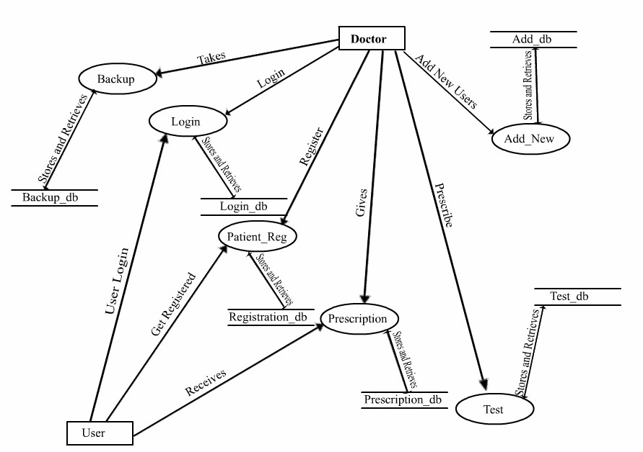

**FIG 2 DFDs**

**Level 0 DFD**

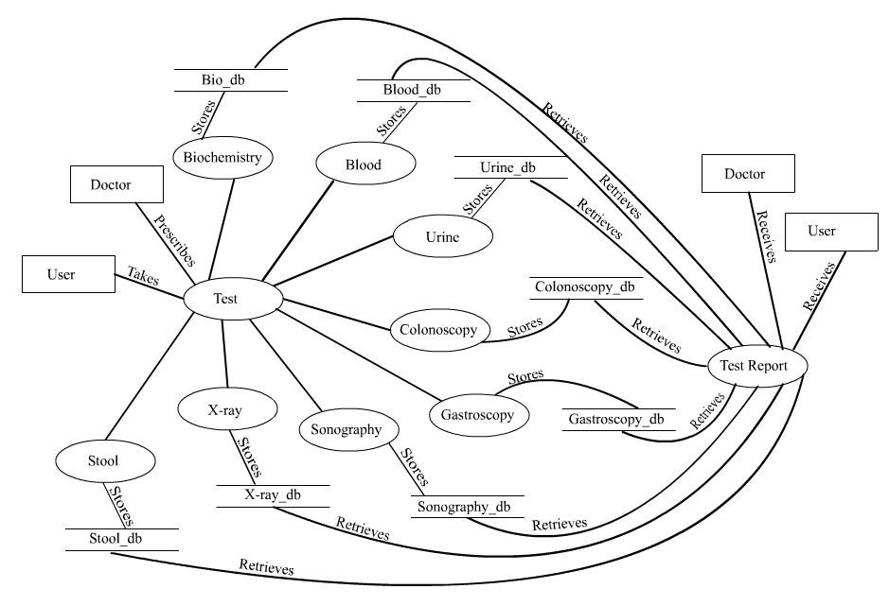

**Level 1 DFD**

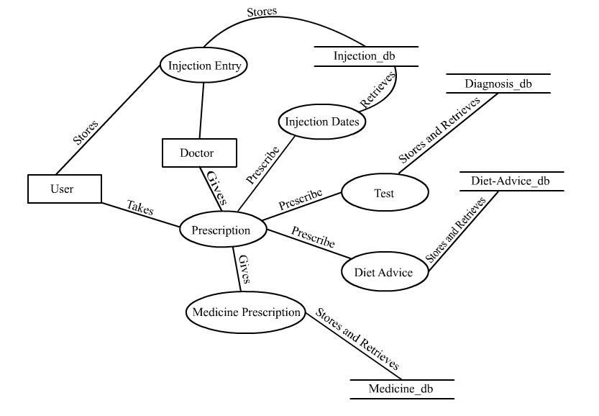

**4.2.2 Context Diagram level 0**

**Fig 3**

Admin

**Users**

|  |  |
| --- | --- |
| **0** |  |
|  | Automated Hospital Management system |

Staff

The DFD above Fig 3 displays the level 0 of the Automated Hospital management system.

The system consists of three modules that’s the User, staff and the admin.Their access levels and privileges will be different and the administrator will have overall authority of the system.

**4.2.3 DFD Diagram to authenticate a user**

Fig 4

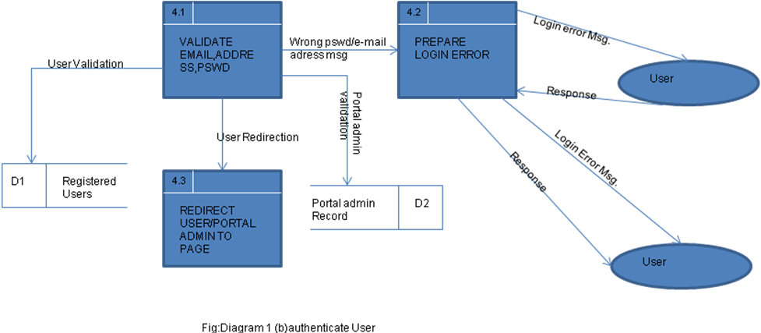

The DFD above Fig 4 shows the processes that a new user to the system must be authenticated first before he/she logs in to the system. It helps to ensure the security and data integrity to prevent manipulation of land information by unauthorized personnel.

**4.2.4 Flowchart for the login session**

Fig 5

Start

If choice=function

Login function

If choice=login

Return

Input password

Input username

YES

NO

The flow chart above shows the login sessions of a customer. If a customer displays the wrong username or password he/she is redirected again to the home page to input the login credentials again.

**4.2.5 Sequence diagrams**

Sequence diagrams helped in the identification of a detailed level of the operations required to implement the functionality depicted by a use case model.

Scenario 1: Admin add new staff

1. The user logs in by providing correct username and password.
2. If username and password are not found on the database access into the system is denied.
3. If the credentials are identical to the ones found on the database, access is granted.
4. User enters the details of the new employee.
5. The user input is written to the database.

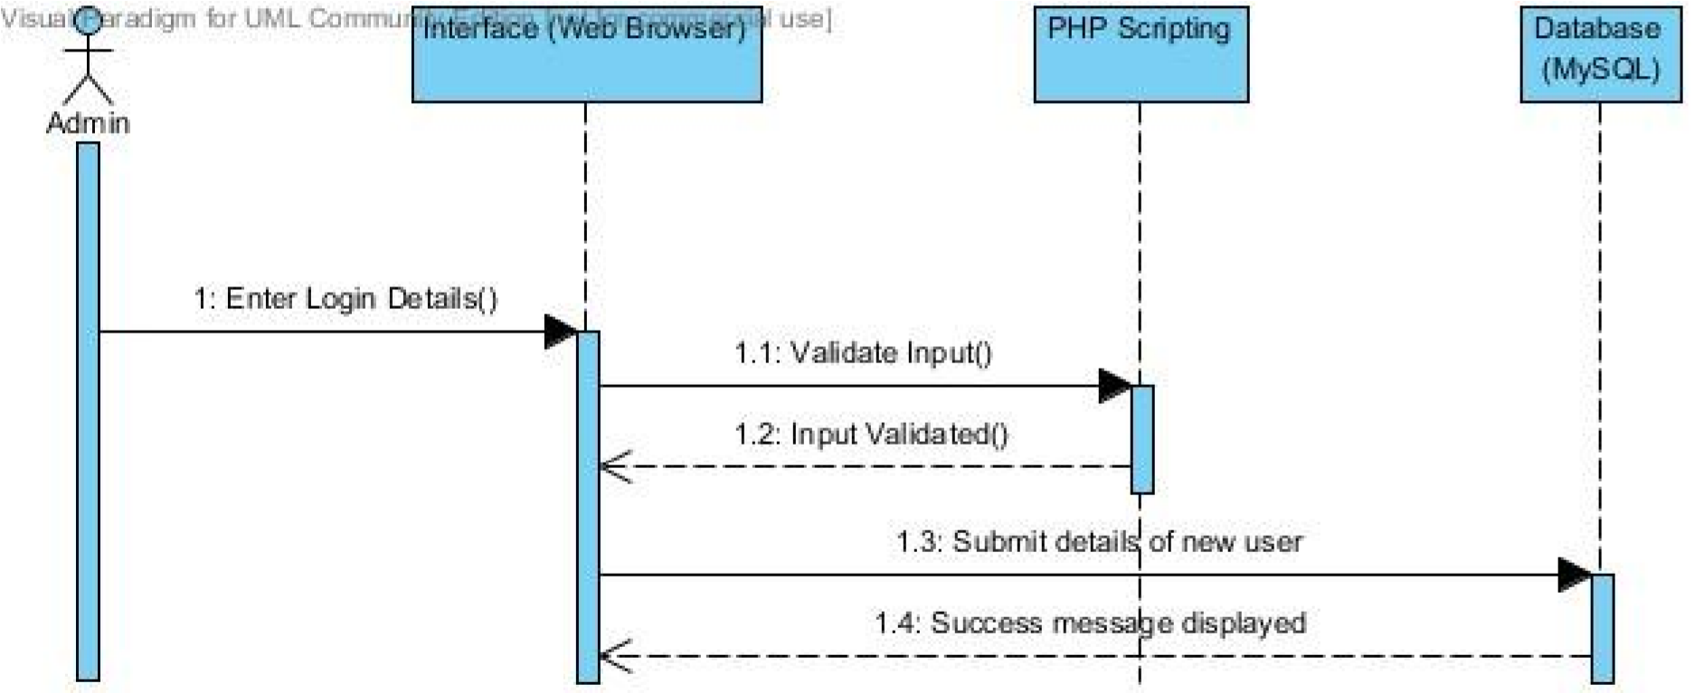

*Figure 6 sequence diagram of admin adding new staff*

**4.3 FACTS FINDING TECHNIQUE**

Data gathering involves collecting thoroughly all the information concerning the existing system. The following are the techniques that in applied to gather all the fact from the existing system.

**4.3.1 Interviews**

It’s a two way exchange conversation where questions are asked by the interviewer to elicit facts or statements from the interviewee. In my research I used the individual interview where I laid an interview layout to obtain the information from the Tabibu Hospital management team that would assist in defining the problem definitions. I formulated the following questions.

1. How many members are currently working in your accounting department?
2. What mode of application do patients use when they come to the hospital and want to see the doctor?
3. Tell me what you would like to be entailed in your system?
4. What are the challenges you as a cashier face with the manual system?
5. Why are you admiring to have a computerized system?

**4.3.2 Questionnaires**

Questionnaires were also used to collect information. The questionnaires contained multiple choice enclosed questions and structured objectives with general answers whereby the respondents selected the choice that applied to their environment.

***NB: Questionnaire layout in the Appendix I***

**4.4 SYSTEM REQUIREMENTS**

**4.4.1 Non Functional Requirements**

***Efficiency Requirement*** -When the Automated Hospital management system was implemented clients and staffs easily accessed system and generated the reports at a faster rate. It took the staff fewer time to generate them since the system could generate them electronically and there were no errors encountered.

***Reliability Requirement*** -The system accurately performed member registration, member validation, and report generation.

***Usability Requirement*** The system was designed for a user friendly environment so that clients and staffs of the Hospital management team performed the various tasks easily and in an effective way. This was enhanced by use of friendly user interfaces that were attractive to the clients.

***Implementation Requirements*** -In implementing whole system was used html in front end with php as server side scripting language which was used for database connectivity and the backend i.e. the database part was developed using MySQL. The MYSQL helped in the storage of the tables for the POST. These tables contained information such as usernames, passwords and staff personal details.

***Delivery Requirements*** The whole system is expected to be delivered in six months of time with a weekly evaluation by the project guide.

**4.4.2 Functional Requirements**

* **User authentication-**The system validated users accessing data in the system through use of usernames and passwords validation and verification which eventually enhanced integrity and confidentiality since only authorized users were able to access the system.
* **Data Entry, Storage and Retrieval-**Records were inputted using forms and be stored in the database. Users queried the system for information based on certain criteria.
* **Report Generation-**The developed system allowed the staff to print reports for the patients and general hospital reports.

**4.5 Software and Hardware Requirements**

This section described the software and hardware requirements of the system

**4.5.1 Software Requirements**

1. **Operating system**- Windows 7 was used as the operating system as it is stable and supports more features and is more user friendly
2. **Database MYSQL**-MYSQL was used as database as it was easy to maintain and retrieve records by simple queries which were in English language which were easy to understand and easy to write.
3. **Development tools and Programming language**- HTML was used to write the whole code and develop webpages with css, java script for styling work and php for sever side scripting.

**4.5.2 Hardware Requirements**

1. Intel core i5 2nd generation was used as a processor because it was faster than other processors and was reliable and stable and can run our pc for long time. By using this processor we can keep on developing our project without any worries.
2. Ram 4 gb was used as it provided faster reading and writing capabilities and in turn supported the processing.

**4.6 SUMMARY**

The core and emphasis of this chapter was the analysis of the current system. The various development tools used in the project were also discussed in this chapter. The next chapter will focus on the design characteristics and aspects of the system to be developed.

**CHAPTER FIVE**

**SYSTEM DESIGN**

**5.0 Introduction**

This chapter builds on the work done in the System Analysis Chapter and gives documentation for the Design of the Automated Hospital Management System (AHMS). The AHMS was modelled in terms of objects and classes and their interactions with each other. The interphase designs for the system were included in this chapter.

**5.1 Screenshots of the system designs**

***Interface of the logins page***

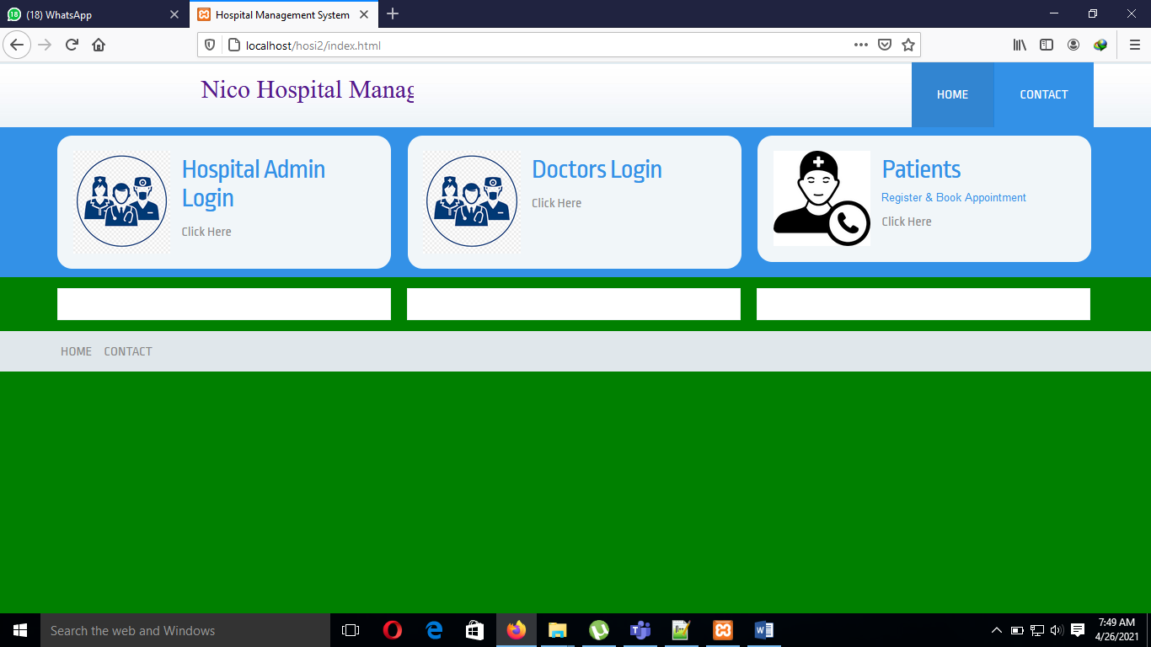

***Interface of the admin homepage***

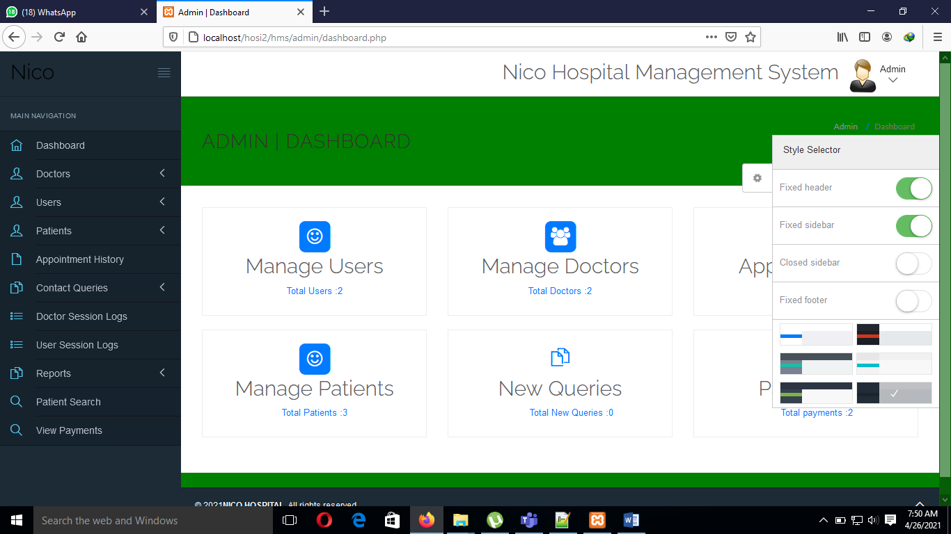

***Interface of the admin dashboard to add a doctor***

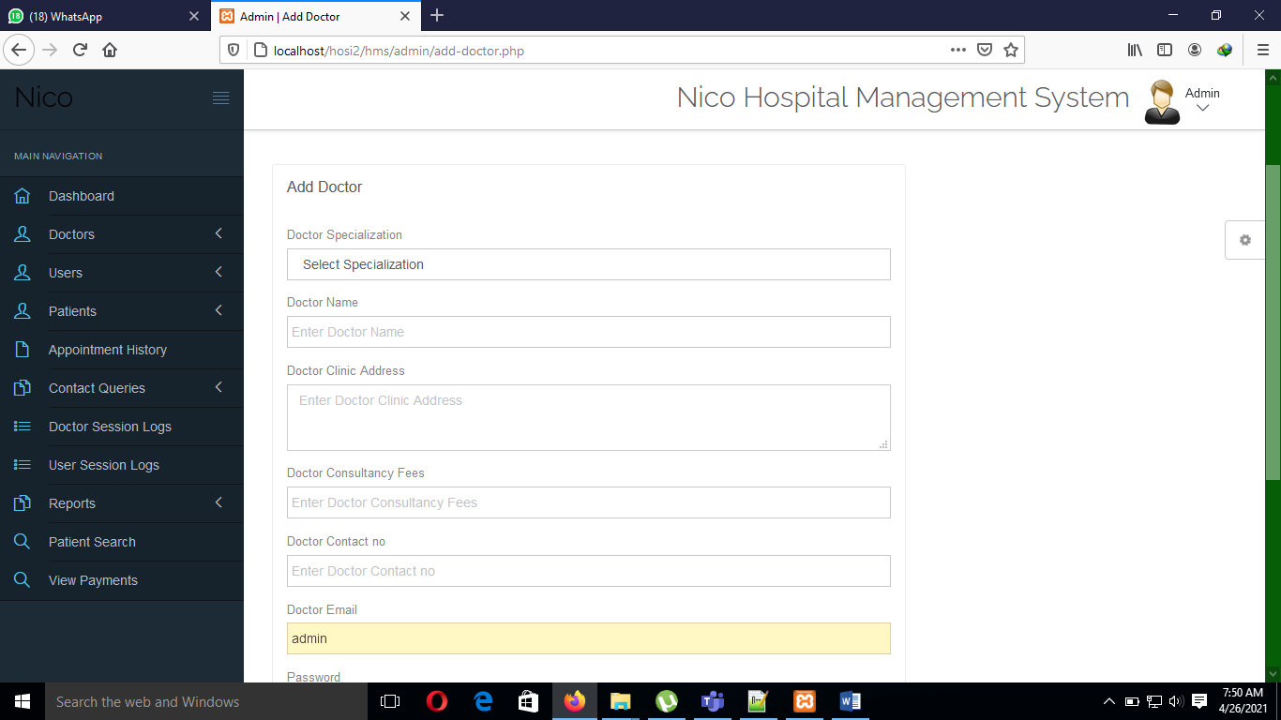

***Interface of the patient page***

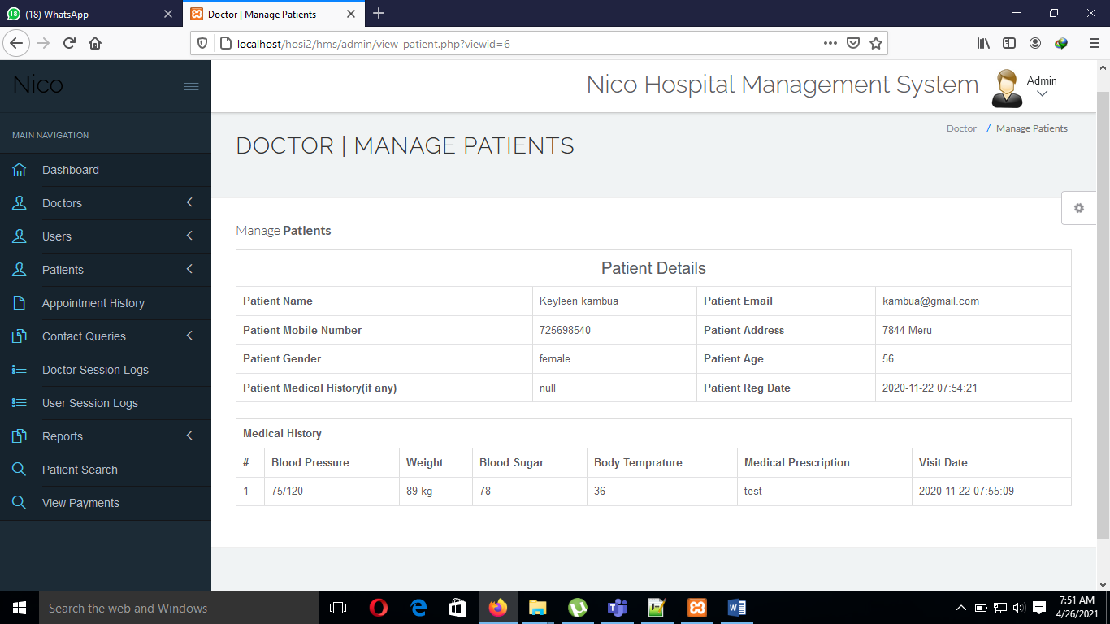

**5.2 Physical Database Design**

**Table 2: Medicine Table**

|  |  |  |  |
| --- | --- | --- | --- |
| **Field** | **Field Name** | **Field Type** | **Description** |
| Medicine id | Medicine_id | Number | Primary key for the medicine table |
| Name | name | Text | Stores the medicine name |
| Medicine Category Name | Medicine_category_ name | Number | Stores the category of the medicine |
| Description | Description | Text | Stores the detailed description of the medicine |
| Price | price | Text | Stores the medicine price |
| Manufacturing company | Manufacturing_company | Text | Stores company producing the medicine |
| Status | status | Number | Stores the no of drugs available |

**Table 3: Admin Table**

|  |  |  |  |
| --- | --- | --- | --- |
| **Field** | **Field Name** | **Field Type** | **Description** |
| Admin ID | adminid | Number | Primary key for the admin |
| name | name | Text | Stores name of the admin |
| email | email | Text | States the admins email address |
| password | password | Text | States the password for the admin |
| address | address | Text | Stores the address |
| phone | Phone | Number | Stores the contact for the admin |

### 5.3 Entity Relationship Diagram

FIG 7

have

user s

Admin

Login

password

take

Backup

do

do

give

write

write

Login

Patient

Prescription

Test

Patient

Reg.

Test

give

prescription

do

login

password

do

Login

kk

AHMS

**CHAPTER SIX**

**IMPLEMENTATION AND TESTING**

**6.1 Introduction**

This chapter explored the different aspects concerned with the implementation of the developed system. This project was concerned with the development and implementation the Automated Hospital management system. We began with analysis of the current and proposed systems, the design of the system to be developed, and in this chapter we dwelt with implementation of the developed system.

**6.2 Coding and Testing Tools**

To be able to meet the project main objective of developing a web based application that can be accessed by the use of a web browser, the system has been developed using PHP .PHP application is to be hosted in a webserver i.e. Internet Information Services (IIS) from where it can be accessed by use of a defined Uniform Resource Locator (URL).

PHP supports used of basic HTML tags that have been used in creating the user interfaces. To be able to come with user friendly interfaces, CSS and AJAX Toolkit have been used in order to achieve this.

The business logic of the application has been implemented using java programing language that is object oriented. The advantages of using java which as an object oriented programing language include: improved software-development productivity due to its modularity and re-usability approach, improved software maintainability, faster development due to re-use of objects and code as indicted by The Saylor Foundation (2015). The modular approach enabled me with coming up with the three portals that form the system, namely the administrator, officers and the public portals.

To meet the objective of having a centralized database, the application has been developed using the MS SQL Server database that is used for storing the application data.

**6.3 MYSQL TRIGGERS**

**6.3.1 Implementation of MySQL Triggers**

In MySQL, a trigger is a set of SQL statements that is invoked automatically when a change is made to the data on the associated table. A trigger can be defined to be invoked either before or after the data is changed by INSERT, UPDATE or DELETE statements. MySQL allows you to define maximum six triggers for each table.  
  
• BEFORE INSERT – activated before data is inserted into the table.  
• AFTER INSERT- activated after data is inserted into the table.  
• BEFORE UPDATE – activated before data in the table is updated.  
• AFTER UPDATE - activated after data in the table is updated.  
• BEFORE DELETE – activated before data is removed from the table.  
• AFTER DELETE – activated after data is removed from the table. When you use a statement that makes change to the table but does not use INSERT, DELETE or UPDATE statement, the trigger is not invoked.

**6.4. System installation**

The system was developed and tested on a laptop computer running Windows 7, and the WAMP Server. In order for the Web application to be accessible via the Internet it will have to be installed on a Web Server running Apache, PHP and MySQL. The suitable operating system for the web server will be Linux as it is more stable and less prone to virus but a windows based platform will equally do the job just as well. A suitable domain name will have to be chosen and registered in order for the web application to be accessed via a URL and hosting and administration fees paid to the web hosting company of choice either annually or monthly depending on the package and terms agreed upon. The web application will be accessible via most of the popular web browsers on the market. A suitable web browser e.g. Mozilla Firefox will have to be installed on the client machine wishing to access the web application.

**6.5 Algorithms (**MD5 Encryption)

MD5 algorithm was used for password encryption. MD5 stands for **Message**  
**Digest** algorithm **5** is a widely used cryptographic hash function. The idea behind this algorithm is to take up a random data (text or binary) as an input and generate a fixed size “hash value” as  
the output. The input data can be of any size or length, but the output “hash value” size is always fixed. Here is an example (Figure 8) of MD5 Hash function at work

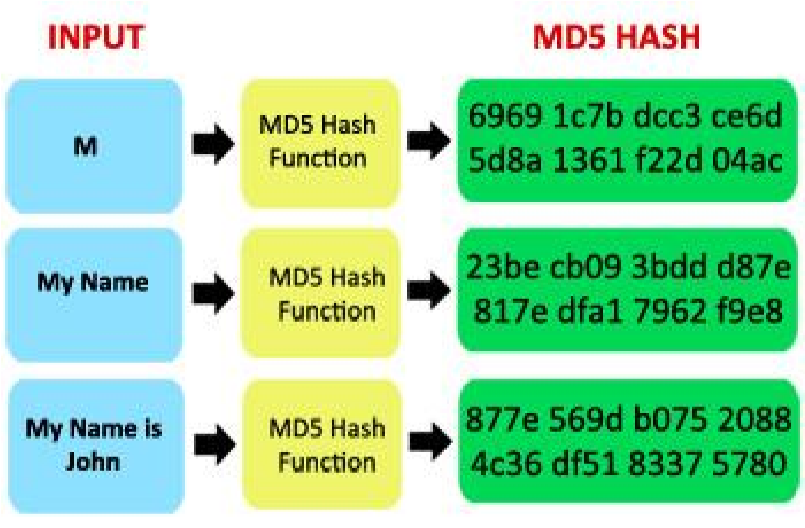

***Figure 8 MD5 Encryption procedure***

As can be seen from the above example, whatever input size is given, the algorithm generates a fixed size (32 digit hex) MD5 hash.

**6.6 SYSTEM TESTING**

**6.6.1 Testing goals**

The goals in testing this system included validating the quality, usability, reliability and performance of the application. Testing was performed from a black-box approach. Tests were designed around requirements and functionality.

**6.6.2 Black-box approach**

Black box testing methods focused on the functional requirements of the system, i.e. black box testing enabled the system developer to derive sets of input conditions that will fully exercise all functional requirements for a system.

Black box testing attempted to find the errors in the following categories;

1. Incorrect of missing functions.
2. Interphase errors
3. Errors in data structures or external database access.
4. Performance errors.

**6.6.3 Strategies used for testing**

**Unit Testing**-It focused on the verification of the smallest unit in the system design in each module. It involved testing the;

***Testing administrator login form***-This form was used to log in the administrator of the system. In this we entered the username and password if both were correct administration page opened otherwise if any of data was wrong it redirected back to the login page and again asked for username and password.

***Test for staff login form***- This form was used to log in the staff .In this we entered the username and password if all these were correct staff login page opened otherwise if any of data was wrong it redirected back to the login page and again asked for username and password.

**Integration Testing**-Is a systematic technique for constructing the system structure while at the same time conducting tests to uncover tests to uncover errors associated with interfacing. The primary objective was to test the module interfaces in order to ensure that no errors are occurring when one module invokes the other module. I tested the system on how each page links or redirects to another page. Example. The cashier login page and the user profile page.

**System Testing**-I conducted the performance testing to test the run-time performance of system.

**6.7 System Test Plan**

A test plan is a document detailing the objectives, target market, internal beta team and processes for a specific beta test for a software of hardware product. The purpose of a test plan was to show how each module of the system was tested to enhance efficiency and security.

***Table 4***

|  |  |  |
| --- | --- | --- |
| Functional  Requirement No. | Test  Case No. | Test-Case Short Description |
| FR01 | TC01 | To test the Login/Authentication interface for the Admin |
| FR02 | TC02 | To test the Login/Authentication interface for the users |
| FR03 | TC03 | To test, users can view the resources. |
| FR04 | TC04 | To test, Admin can upload new drugs. |
| FR05 | TC05 | To test, Admin can register new users. |
| FR06 | TC06 | To test, Admin can view all the users registered in the system |

**6.7.1 Test Case Results**

This section lists the results that were produced by running the test cases. Table 6 lists the test cases that were used while testing the interface along with the expected result and the actual results for each test case.

**Table 5.** List of Test-Case Results.

|  |  |  |
| --- | --- | --- |
| Test Case Number | Expected Result | Actual Result |
| TC01 | Pass | Pass |
| TC02 | Pass | Pass |
| TC03 | Pass | Pass |
| TC04 | Pass | Pass |
| TC05 | Pass | Pass |
| TC06 | Pass | Pass |

**6.8.1 Tools used for testing the system**

It involved the use of automated testing tools such as;

***Code auditors***-These are special purpose tools were used to check the quality of the system to ensure it met the minimum coding standards.

***Test data generators***-These tools assisted in selecting the test data that made the system behave in a particular manner. Example of the automated tool was the FRET. This tool was used to test the entire system thus it reduced the time that I could spend on testing all the different features of the system dramatically. I used it to test the features of the system in all kind of browsers. I performed this to ensure that the system behaved as it was supposed by verifying the user requirements with the management.

**6.8.2 Proposed change over techniques**

***Parallel Changeover***-The new system runs simultaneously with the old system for a given period of time. It’s effective since it carries the lowest risk. If something goals wrong at any point, the entire system can be reverted back to its original state. It provides greater security in terms of data and resources.

**6.9 Summary**

This chapter has outlined how the Automated Hospital management system has been implemented using the MSQL Triggers. The method selected for systems change-over has been highlighted and justified, lastly the chapter concludes by showing how the system can be deployed and tested. This brought to light why it is very cardinal to test a new system before it is introduce on the main stream of an organization’s business.